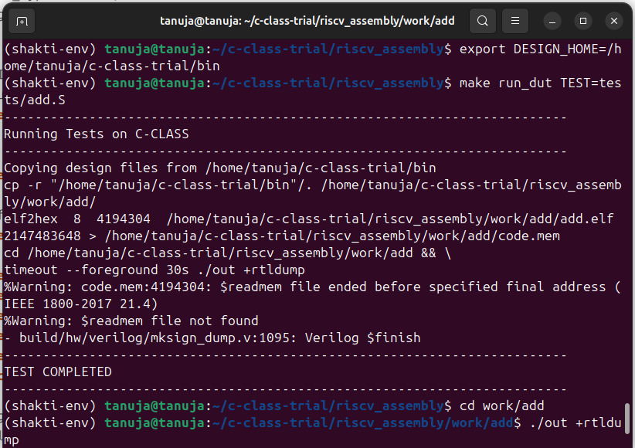

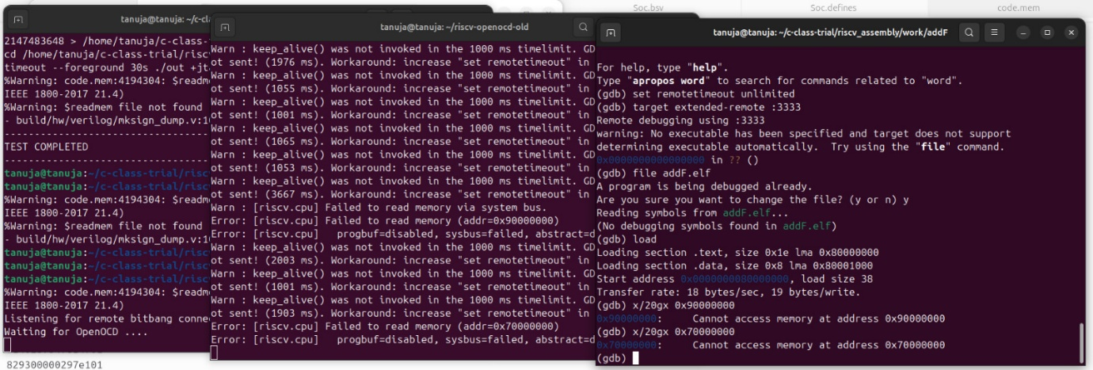

We face this error which mapping the BRAM to address 0x90000000. GDB can’t access it and trace the PC .